|  |
| --- |
| Circle Language Spec: Relations |

## Referrers

### Concept

Objects contain references to other objects. At first, a referenced object is not aware of its referrers, but it is also an option for an object to register all its referrers in a list.

The referrers are not the parents containing the references to the object, but the referrers are the *references* to the object themselves.

When a related item is set to point to a certain object, the Related Item . Object . Set command will update the target’s list of Referrers. So the *referrers* update the target’s Referrers list. The referenced object does not update the Referrers list itself.

The Referrers list consists of references *back* to the referrers, but that does *not* mean the object in turn becomes a referrer of the referrer again.

An object can have a referrers list, but an object reference, so a related item or related list item (see the *System Objects* articles), can also have its own referrers list for references that refer to references.

#### Not Supporting the Referrers Concept

An object could choose not to support the Referrers concept, if the programmer knows, that this object will be referenced so many times, and there is so little interest in knowing all its referrers, that it would be ridiculous maintain a list.

But by default, the Referrers concept is always supported.

### Diagram Notation

The referrers of an object are simply displayed as a sub-list called Referrers, every item of which points back to the references to the object:

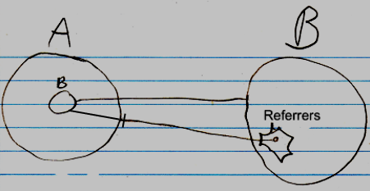

The entry in the Referrers list is pointing to a related item in the parent object A, not directly to an object.

The lines coming out of the referrers list are usually not shown, because a line tied *to* an object already *implies* a referrer. The diagrams will have more features later, and the referrer lines would obscure the picture.

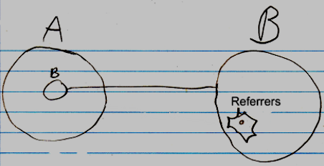

Even the whole referrers list may even be left out of the diagram by default, but it is not clear yet, if that is the way to go.

If something refers to a reference, then this may look like this in a diagram:

b in A is a reference to the reference to c inside B. To display the referrers in the diagram, you could <>do something like this<>:

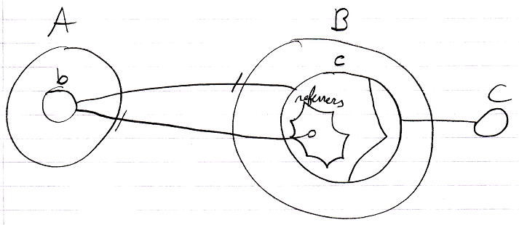

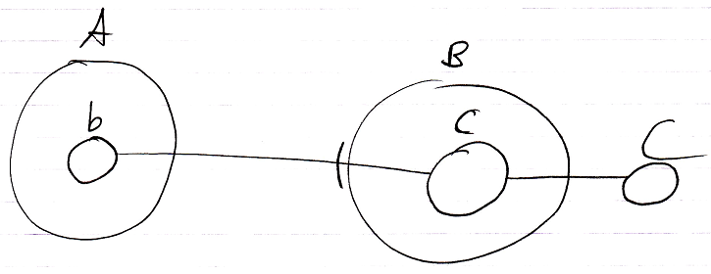

## Ideas

Taken out of the Referrers article:

<Compared to giving a number class a related list for every class that uses integers>

A number class could, however, choose to support a single list of all referrers. Then a number object will have only one related list. Numbers may be used by many classes, but an individual number object, is never used much. It is not a lot of data to register inside an integer object, which objects refer to that particular number.

JJ

Referrers,

2008-08-10

The Referrers concept needs to be redone.

Consider the system interface and make sure

you can register referrers in a reference,

as well as referrers to an object,

and consider whether you want the referrers

list to point to references or the the parents of the references.

The article Referrers in a Diagram, Class Referrers in a Diagramand Command Definition Referrers in a Diagram are involved.

I was looking at the Refferes diagrams. It’s not correct. The referrers list registers the parents of the references. I’m thinking now: they should register the references themselves. I must have been that I was unaware of the workings of the system interface back then…

JJ

Referrers,

2008-08-28

Referrers has to be redone. It has to become a list of related items and related list items, that they are inside their parents.

Redoing Referrers was postponed in the project Work Out Basic Command Articles, because it involves too much other material, that takes too much time to go into.

Referrers is mainly part of Relations.

You are probably going to have to read over the whole Relations article group.

The following articles may have to be redone, when redoing Referrers:

- Referrers

- Referrers in a Diagram

- Class Referrers

- Class Referrers in a Diagram

- Referrers Versus Related Objects

- Command Object Referrers

- Command Object Referrers in a Diagram

- Command Definition Referrers

- Command Definition Referrers in a Diagram

JJ

Referrers,

2008-08-28

The referrers articles are not finished, because referrers needs to be reconsidered later, and it involves much different material, that takes time to go into.

- I hate it, that I could not finish the referrers articles.

- But it is too much to go into just like that.

- I have to accept that the produced article group will contaiin two subjects, that are not finished.

JJ